29.48: a) Choose the area vector to point out of the page. Since the area and its orientation to the magnetic field are fixed, we can write the induced emf in the 10 cm radius loop as
After solving for 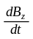 and integrating we obtain
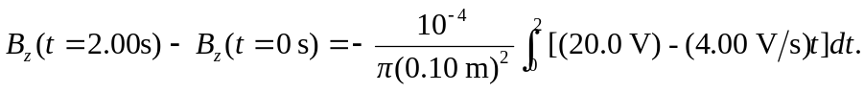
Thus,
b) Repeat part (a) but set to obtain 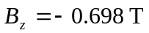
c) In part (a) the flux has decreased (i.e., it has become more negative) and in part (b) the flux has increased. Both results agree with the expectations of Lenz’s law.

